Visual Basic Screenshots #12 – Functions and Subs - Tom H

1. Functions return a value, subs don’t. A sub is a piece of code that will be executed and that can change according to the input.
2. 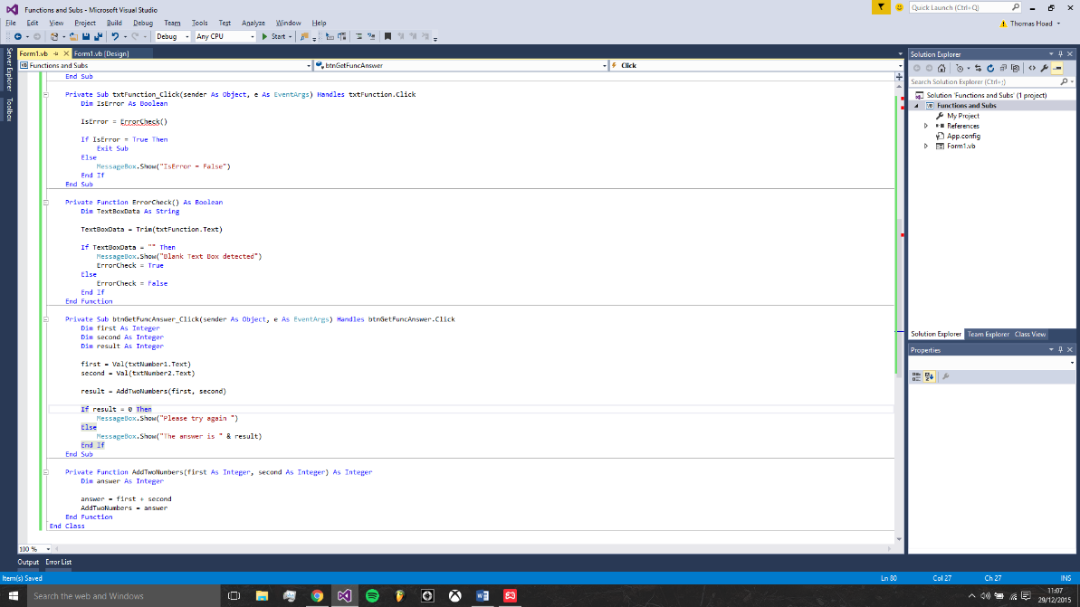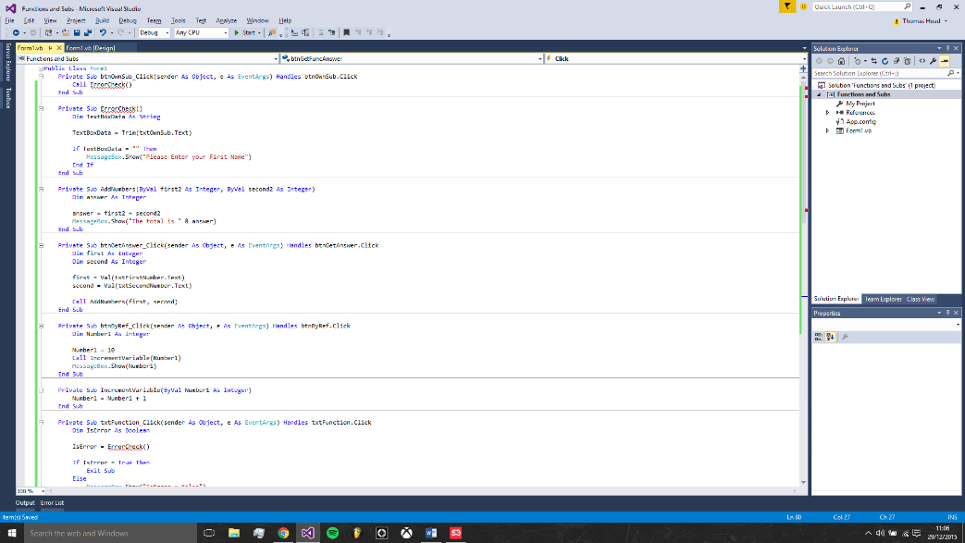When you pass arguments over to Subs and Function you can do so either By Value or By Reference. By Value is shortened to ByVal and By Reference is shortened to ByRef. ByVal means that you are passing a copy of a variable to your Subroutine. You can make changes to the copy and the original will not be altered. Visual Studio hides ByVal from you most of the time. It's hidden because ByVal is the default when you're passing variables over to a function or Sub. ByRef is the alternative. This is short for By Reference. This means that you are not handing over a copy of the original variable but pointing to the original variable.